CESSNA 140 Checklist
Specifications for Continental O-200-A

SPECS
- MTOW 1450 (lbs)
- OEW 974 (lbs)
- Payload 476 (lbs)
- Useable Fuel (minimum 3g each tank) 19 (g)
- Oil (absolute max 7qt) 4qt. (min) 5qt. (max)
- Oil Consumption 0.6 Qts/h
- Tire Pressure Main 16 to 18 (lbs/sq in)
- Tire Pressure Tail 15 to 30 (lbs/sq in)
AIRSPEED
- Pwr On Stall Dirty (+3 kts Clean) 32 (KIAS)
- Vs0 39 (KIAS)
- Vs 43 (KIAS)
- Short Field (Flaps 40°) 51 (KIAS)
- Approach (Flaps 40°) 56 (KIAS)
- Approach (Flaps Up) / Vbg (~1.5NM per1k’) 61 (KIAS)
- Vx 56 (KIAS)
- Vy 63 (KIAS)
- Normal Climb 64 to 70 (KIAS)
- En Route Climb 70 to 80 (KIAS)
- Vfe 71 (KIAS)
- Va (1100 lbs) 80 (KIAS)
- Va (1300 lbs) 87 (KIAS)
- Va (1450 lbs) 92 (KIAS)
- Vno 100 (KIAS)
- Vne 122 (KIAS)
LIMITATIONS
- Tach (rec 60 bhp) 2000 to 2600 (rpm)
  - Cruise: 2400 (Low/Cold) -2600 (Hot/High)
- Tach No Go -20°C ISA <8k’ 2600 to 2750 (rpm)
- Tach Max 5m climb 2750 (rpm)
- Oil Pressure R: <10 - G: 30 to 60 - R>100 (psi)
- Oil Temp Y: <75° -G: 75° to 225° - R: >240° (F)
- Cylinder Head (rec. <350) Y: <200° - G: 200° to 400° - R: >525° (F)
PERFO.
- Takeoff Roll @ ASL/ISA 663’
- Landing Roll @ ASL/ISA 302’
- Max. Crosswind 9 kts
- Fuel (78% bhp) 5.9 (g/hr)
- Range @ ASL/ISA (3.5g) 6h17m
- Range (>ASI drop): Fly High / Endurance (=Alt): Fly Low
- Service Ceiling 15 500’
Performance Chart
+0.8g Runup
>time, fuel & distance by 10% for each 8°C above ISA
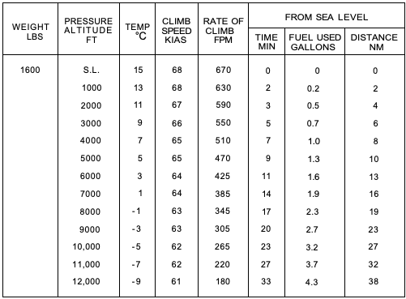
Recommended Lean Mixture (from C150)
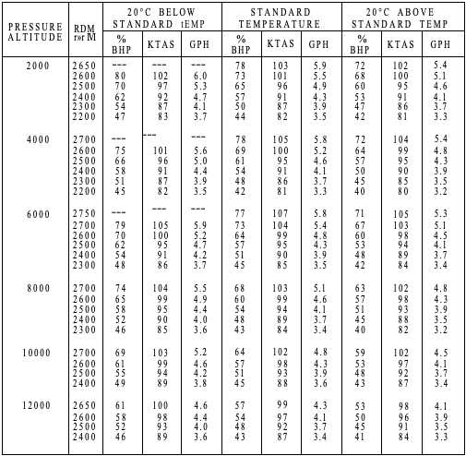
*Lean ROP - EGT: +50°F to +100°F – CHT: <350°F
IAS | 40 | 60 | 80 | 100 | 120 | 140
CAS | 46 | 65 | 83 | 100 | 116 | 133

PREFLIGHT

COCKPIT
- Mag OFF
- Fuel CHECK QTY
- Rudder & Brake Linkage SECURE
- Hydraulic Brake Reservoirs NO LEAKS
- Control Cable Attachment SECURE
- Seat belts (no passenger) STOWED
- AROWJIL SECURE

LANDING GEAR
- Attachments SECURE
- Hydraulic lines NO LEAK (Red Fluid)
- Brakes CHECK
- Tire & wheel hub CHECK
- Gear Box NO CRACK

WING
- Strut attachment SECURE
- Aileron attachment SECURE
- Aileron MOVE FREELY
- Spar check SOME FLEX
- Fabric NO DAMMAGE & WRINKLES
- Leading Edge NO CONTAMINENTS
- Check fuel level 25g MAX
- Fuel Cap SECURE

ENGINE
- Windshield CLEAN
- Engine Oil Level 4 MIN 5 MAX
- Engine Oil Dipstick SECURED
- Fuel drain SAMPLE
- No Significant Oil Leaks
- Propeller & Spinner DENT/NICK
- Cowling pins SECURE
- Exhaust pipe NO HOLES/CRACKS

AIRFRAME
- Skin (including belly) DAMMAGE
- Rivet NO GRAPHITE COLOR
TAIL
- H-Stab & Trim SECURE & FOD FREE
- Flying wires & bolts SECURE
- V-Stab SECURE
- Elevator & Rudder hinges SECURE
- Rudder & Elevator MOVE FREELY
- Steering springs and chains IN PLACE
- Leaf spring (check bolts) SECURE

ENGINE START
- Time RECORD
- Radio OFF
- Master ON
- Fuel tank LOWEST TANK SELECTED
- Carb Heat OFF
- Mags ON
- Prime 3 to 5 TIMES (COLD ONLY)
- Brakes SET
- Throttle 1/4’ CRACKED (800 rpm)
- Stick FULL AFT
- Starter PUSH
- Oil Pressure (30s Warm / 60s Cold) CHECK
- Throttle SET 1000 (rpm)
- Radio ON
*Crack the throttle to ½’ & up if the engine doesn’t start. Use primer as req.

BEFORE TAXI
- Radio CHECK
- Altimeter SET
- Brakes TEST
- Taxi DON’T RIDE THE BRAKE

RUN UP
- AC INTO THE WIND
- Run-up 1700 rpm (Hold Brake Stick Back)
  - Mag Dead MAX Drop 150 & DIF 75
  - Carburetor heat CHECK
- Oil Pressure/Oil Temperature CHECK
- Primer IN & LOCKED
- Instruments CHECK
- Fuel FULLEST TANK SELECTED
- Trim SET FOR TAKEOFF
- Control FREE & CORRECT
- Engine Temp (m75°F) (2m Warm/4m Cold) CHECK
FLIGHT

NORMAL TAKEOFF
- Check wind and apply correction
- Smoothly apply full power
- Check oil temp (75-225°F) / Oil pressure (30-60psi)
- Neutralize controls as aircraft accelerates
- Set slight nose high climb attitude
- Climb Speed 65 kias

WHEEL TAKEOFF
- Check wind and apply correction
- Smoothly apply full power
- Ease stick forward to raise tail
- Check oil temp (75-225°F) / Oil pressure (30-60 psi)
- As tail rises smoothly reduce forward stick pressure to hold aircraft level
- Slight back pressure to fly
- Climb Speed 65 kias

SHORT-FIELD TAKEOFF
- Check wind and apply correction
- Hold full back
- Hold full brake
- Smoothly apply full power
- Check oil temp (75-225°F) / Oil pressure (30-60 psi)
- Release the brakes
- Tail stays low (about 6’ of runway surface)
- Climb Speed 55 kias

IN FLIGHT CHECK (15m)
- Carb Heat ON
- Fuel CHECK (ALLOW ¼ TANK DIFF. MAX)
- DG ALIGN WITH COMPASS
NEEDED DESCENT
- Carb Heat ON
- Throttle ~1500 RPM

3 POINT LANDING
- Carb Heat ON
- Primer IN & LOCKED
- Fuel CHECK
- Approach Speed 50-60 kias
- At touch down stick full back
WHEEL LANDING
- Carb Heat ON
- Primer IN & LOCKED
- Fuel CHECK
- Approach Speed 50-60 kias
- Allow mains to roll smoothly on to the ground
- After the mains are down apply forward stick pressure
- Keep tail up as plane slows
- After tail touches apply full stick full back

SECURING PLANE
- ELT LISTEN 121.5MHz
- Radio OFF
- Throttle LOWEST
- Mags Live Cut CHECK
- Throttle 1000 rpm
- Mixture FULL LEAN
- Mag OFF
- Master OFF
- Time RECORD
EMERGENCY PROCEDURES

ENGINE FAILURE
DURING TAKEOFF ROLL
- Throttle IDLE
- Brakes APPLY GENTLY

IMMEDIATELY AFTER TAKEOFF
- Best Glide 60 kias
- Landing Site SELECT
- Fuel OFF
- Magnetos OFF

ENGINE FAILURE INFLIGHT
- Best Glide 60 kias
- Field SELECT
- Approach HOW
- Carburetor Heat ON
- Fuel CONFIRM ON / LEVEL
- Magnetos ON
- Engine Gauges CHECK
- Primer * IN & LOCKED
- Magnetos Left / Right / Both
- Throttle FULL FORWARD
*Primer can be used with Carb Ice

IF ENGINE RESTARTS
- Carburetor Heat AS NEEDED
- Land as soon as possible

EMERGENCY DESCENT
- Radio MAYDAY
- Magnetos OFF
- Forced Landing EXECUTE
*GFA CRAB

FORCED LANDING
- Best Glide 60 kias
- Radio MAYDAY
- Fuel OFF
- Magnetos OFF
- Door OPEN
- Touchdown Speed 50 kias

ENGINE ROUGHNESS
- Carburetor Heat ON
- Engine Gauges CHECK

ENGINE FIRE In FLIGHT
- Fuel OFF
- Throttle CLOSED
- Cabin Heat OFF
- Airspeed >85 kias

SPINS
- Power IDLE
- Ailerons NEUTRAL
- Rudder OPPOSITE ROTATION
- Elevator RELEASE BACKPRESSURE
*Do not exceed Vne of 122 knots

LOSS OF OIL PRESSURE/ HIGH OIL TEMPERATURE
- Land as soon as practical
- Prepare for imminent engine failure

